**Comparative Farm-gate Life Cycle Assessment of Oilseed Feedstocks in the Northern Great Plains**

**Devin Moeller1, Heidi L. Sieverding1, James J. Stone1\***

1 Department of Civil and Environmental Engineering, South Dakota School of Mines & Technology, Rapid City, South Dakota, United States of America

*Corresponding Author: James.Stone@sdsmt.edu; Phone: +001-605-394-2443

**SUPPLEMENTAL INFPORMATION**

Figure S1. SimaPro system input breakdown by field activity process stage (PRéConsultants 2016).



Figure S2. Weighted average of fertilizer inputs and resulting yield data within the Northern Great Plains (NGP) and each crop management zone (CMZ). The average values were weighted by available crop land within each crop management zone (MAES 2017; NASS 2017; NDSU 2017; SDSU 2010).

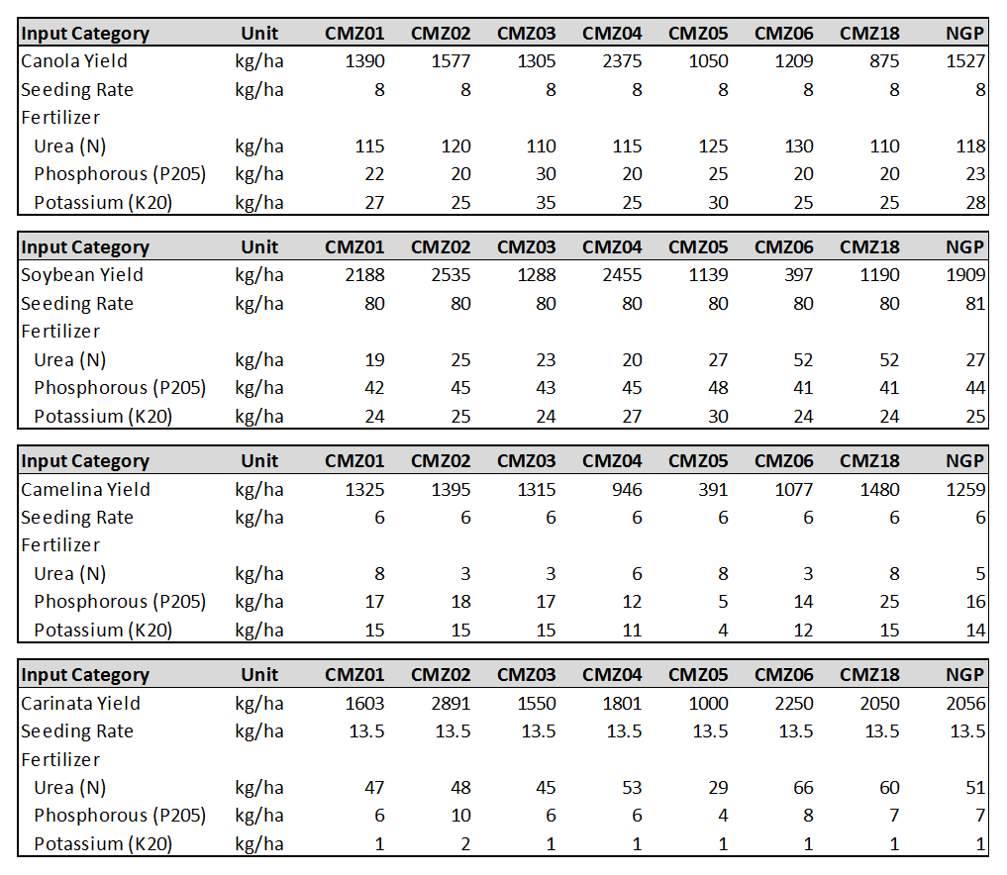

Figure S3. Summary of CMZ01 environmental impacts results based on specific activities for canola, soybean, carinata and camelina. The results are based on 1 kg of product and include the percent contribution from each activity.

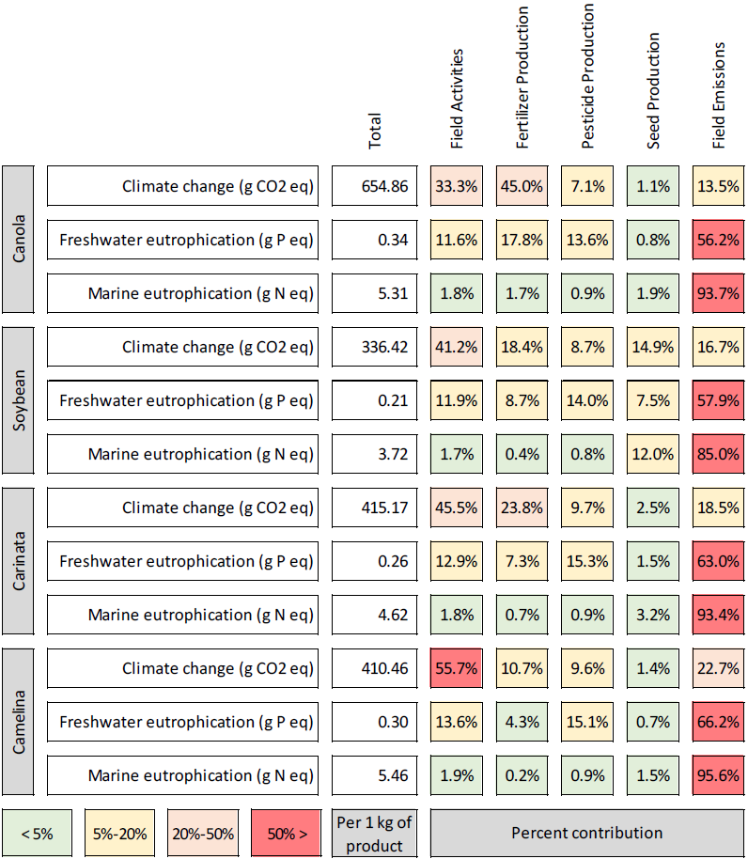

Figure S4. Summary of CMZ02 environmental impacts results based on specific activities for canola, soybean, carinata and camelina. The results are based on 1 kg of product and include the percent contribution from each activity.

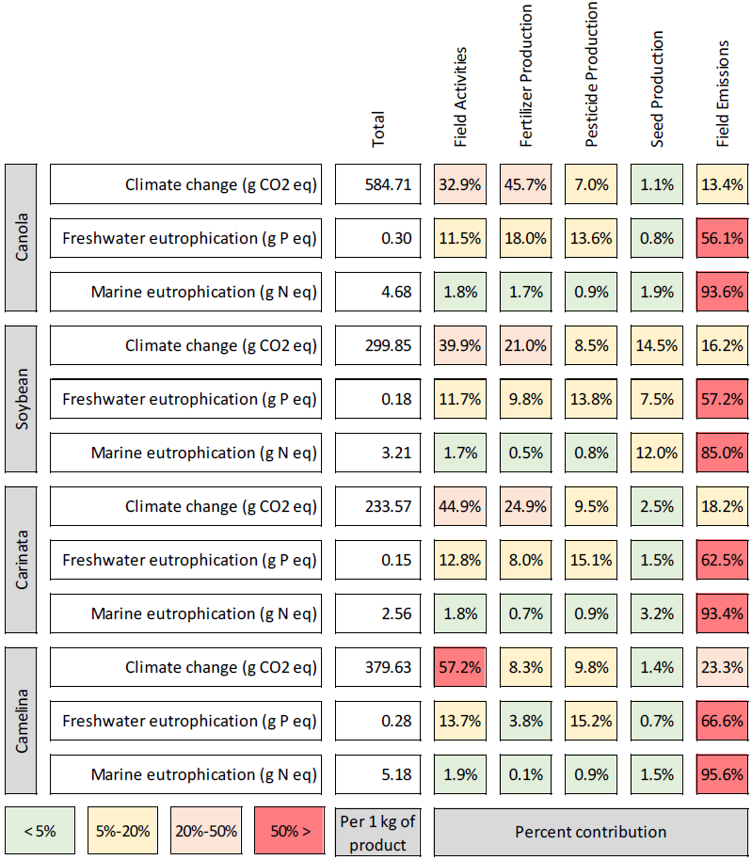

Figure S5. Summary of CMZ03 environmental impacts results based on specific activities for canola, soybean, carinata and camelina. The results are based on 1 kg of product and include the percent contribution from each activity.

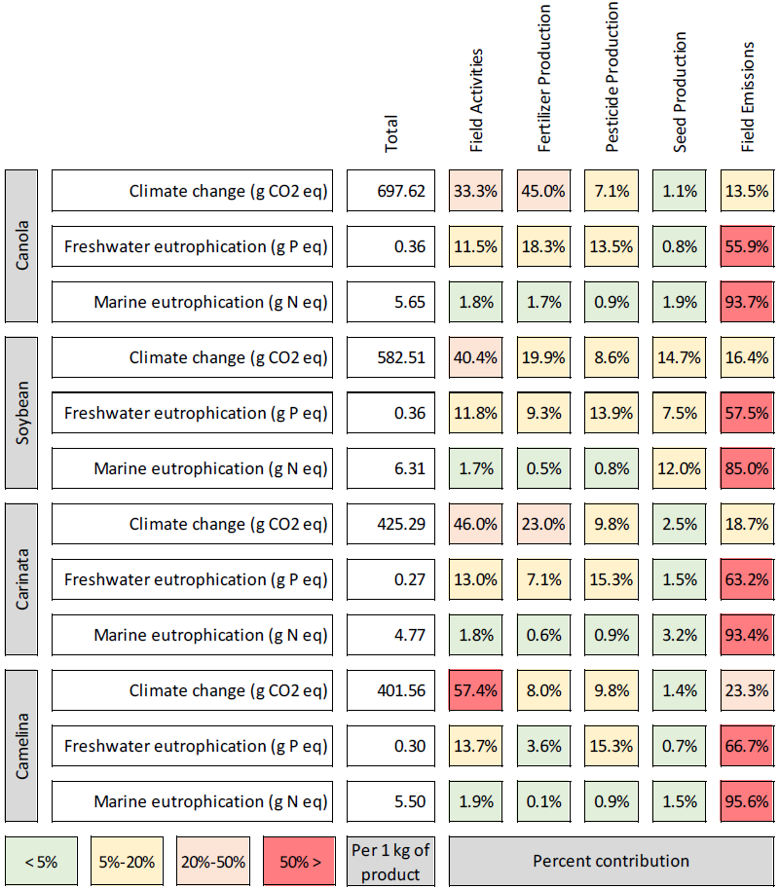

Figure S6. Summary of CMZ04 environmental impacts results based on specific activities for canola, soybean, carinata and camelina. The results are based on 1 kg of product and include the percent contribution from each activity.

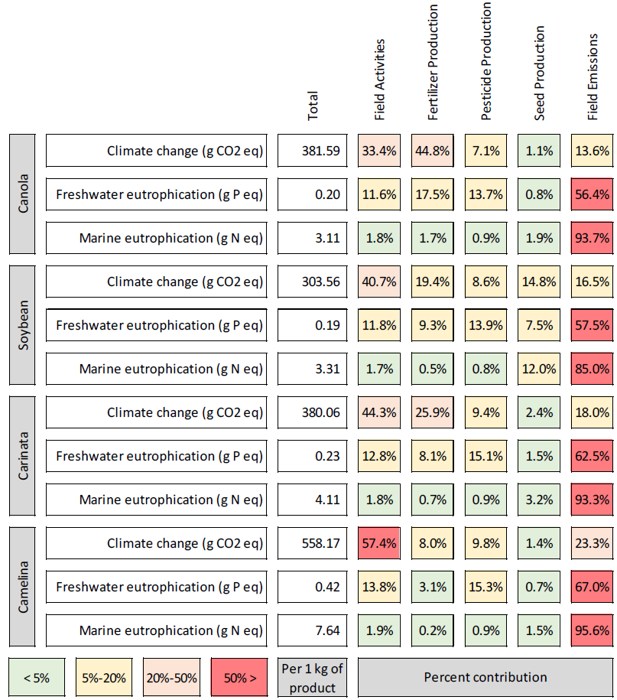

Figure S7. Summary of CMZ05 environmental impacts results based on specific activities for canola, soybean, carinata and camelina. The results are based on 1 kg of product and include the percent contribution from each activity.

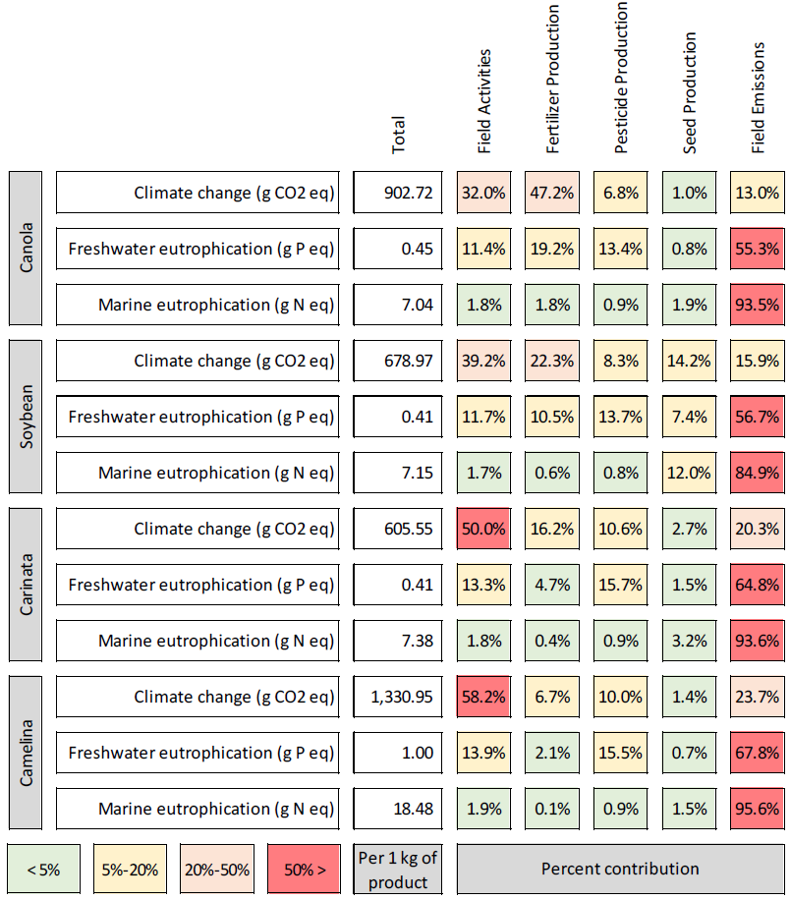

Figure S8. Summary of CMZ06 environmental impacts results based on specific activities for canola, soybean, carinata and camelina. The results are based on 1 kg of product and include the percent contribution from each activity.

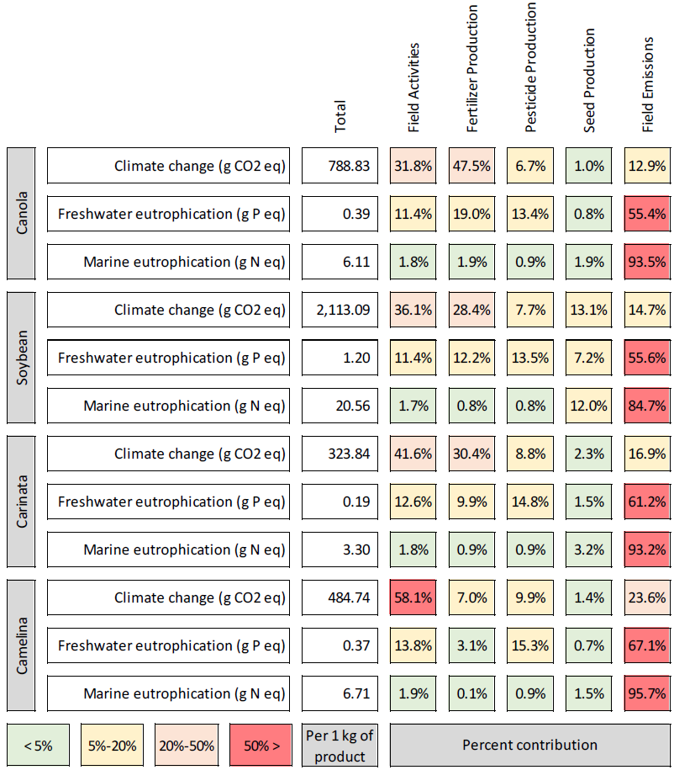

Figure S9. Summary of CMZ18 environmental impacts results based on specific activities for canola, soybean, carinata and camelina. The results are based on 1 kg of product and include the percent contribution from each activity.

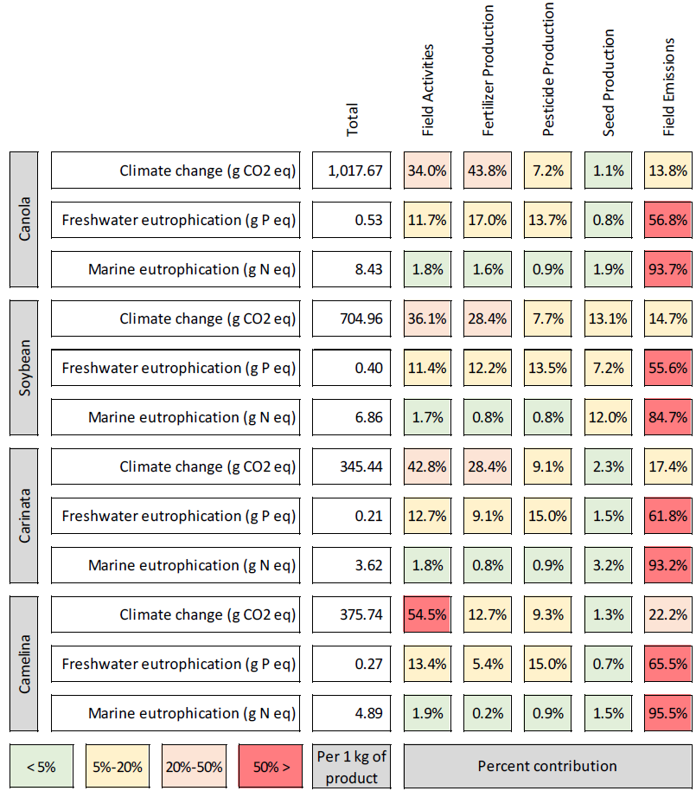

Figure S10. Weighted NGP average summary of the SimaPro uncertainly analysis for environmental impact results presented per kg of product basis. The summary results include the mean and median impact values for the NGP and the standard deviation (SD) and coefficient of variation (CV) for climate change (g CO2 eq), freshwater eutrophication (g P eq), and marine eutrophication (g N eq).



Figure S11. CMZ01 summary of the SimaPro uncertainly analysis for environmental impact results presented per kg of product basis. The summary results include the mean and median impact values for CMZ01 and the standard deviation (SD) and coefficient of variation (CV) for climate change (g CO2 eq), freshwater eutrophication (g P eq), and marine eutrophication (g N eq).



Figure S12. CMZ02 summary of the SimaPro uncertainly analysis for environmental impact results presented per kg of product basis. The summary results include the mean and median impact values for CMZ02 and the standard deviation (SD) and coefficient of variation (CV) for climate change (g CO2 eq), freshwater eutrophication (g P eq), and marine eutrophication (g N eq).



Figure S13. CMZ03 summary of the SimaPro uncertainly analysis for environmental impact results presented per kg of product basis. The summary results include the mean and median impact values for CMZ03 and the standard deviation (SD) and coefficient of variation (CV) for climate change (g CO2 eq), freshwater eutrophication (g P eq), and marine eutrophication (g N eq).



Figure S14. CMZ04 summary of the SimaPro uncertainly analysis for environmental impact results presented per kg of product basis. The summary results include the mean and median impact values for CMZ04 and the standard deviation (SD) and coefficient of variation (CV) for climate change (g CO2 eq), freshwater eutrophication (g P eq), and marine eutrophication (g N eq).



Figure S15. CMZ05 summary of the SimaPro uncertainly analysis for environmental impact results presented per kg of product basis. The summary results include the mean and median impact values for CMZ05 and the standard deviation (SD) and coefficient of variation (CV) for climate change (g CO2 eq), freshwater eutrophication (g P eq), and marine eutrophication (g N eq).



Figure S16. CMZ06 summary of the SimaPro uncertainly analysis for environmental impact results presented per kg of product basis. The summary results include the mean and median impact values for CMZ06 and the standard deviation (SD) and coefficient of variation (CV) for climate change (g CO2 eq), freshwater eutrophication (g P eq), and marine eutrophication (g N eq).



Figure S17. CMZ18 summary of the SimaPro uncertainly analysis for environmental impact results presented per kg of product basis. The summary results include the mean and median impact values for CMZ18 and the standard deviation (SD) and coefficient of variation (CV) for climate change (g CO2 eq), freshwater eutrophication (g P eq), and marine eutrophication (g N eq).



Figure S18. Summary of energy results for each feedstock type for average NGP and each crop management zone. The summary energy results are presented per hectare and include: total cumulative energy demand (Total CED); net energy; energy ratio (EROI); total non-renewable fuel cumulative energy demand (Total NRF CED); and the total percentage of non-renewable fuel cumulative energy demand (Total % NRF CED).



**References**

MAES (2017) Montana Agricultural Research Station.

NASS U (2017) United States Department of Agriculture - National Agricultural Statistics Service, Quick Stats.

NDSU (2017) North Dakota State University Variety Trial Resutls.

PRéConsultants (2016) SimaPro (v8.0). The Netherlands

SDSU (2010) Camelina Production.